Hw 1

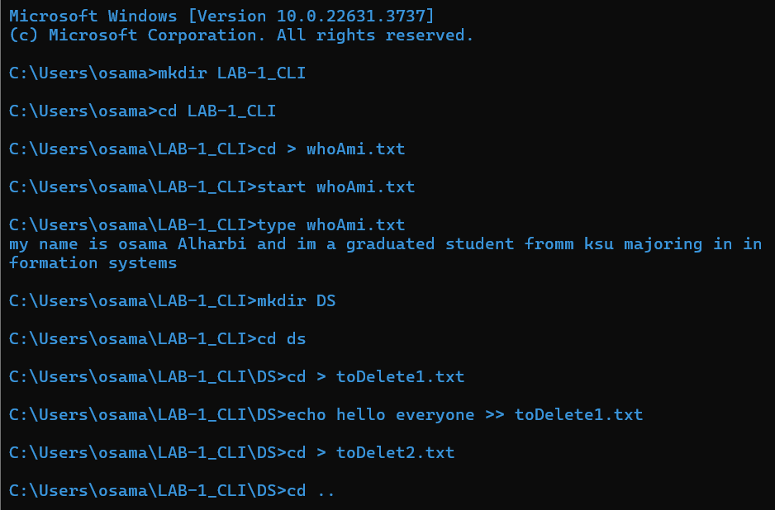

Osama alharbi